**ACKNOWLDGEMENT**

I dedicated to our parents and teacher, who gave us strength when we thought of giving up, who continually provide their moral, spiritual, emotional and financial report. I dedicate this project to **God Almighty** my creator, my strong pillar, my source of inspiration, He has been the source of my strength throughout this program and on His wings only have I soared. I also dedicate this work to***DR.ARFAN JAFFER*** who has encouraged me all the way and whose encouragement has made sure that I give it all it takes to finish that which I have started. I also dedicate this to my friends.

**INTRODUCTION**

The **Teachable Machine** is an effort by Google to make **Machine** Learning and AI accessible to the wider public, without requiring any specialized training, knowledge in Computer Science or coding.No prerequisite machine learning knowledge required.A fast, easy way to create machine learning models for your sites, apps, and more no expertise or coding required.

**CLASSES** I have add 2 classes live with use imges such as book or register

**STEPS:**

BASICALLY THIS PROJECT CONSIST OF THE THREE STEPS

1. GATHERING OF PICTURE 2. TRANING

3.EXPORT

**WORKING OF MACHINE**

You train a computer to recognize your images, sounds, and poses without writing any machine learning code. Then, use your model in your own projects, sites, apps, and more.Now in this project I train the 2 different pictures and then train the data when I train the data I saw the class of objects when match it show the result 100 percent some of them no 100 percent due to similarties of the things

**COMPONENTS**

This repository contains two components of Teachable Machine: A libraries section that contains all of the machine learning code used in Teachable Machine. Under the hood we use Tensorflow.js, a library for machine learning in Javascript, to train and run the models you make in your web browser. The libraries section also contains the API for image, audio, and pose helper libraries that make it easier to use the models exported by Teachable Machine in your own projects. A snippets section that contains markdown snippets that are being displayed inside the export panel in Teachable Machine. These snippets contain code and instructions on how to use the exported models from Teachable Machine in languages like Javascript, Java and Python

**IMAGES**

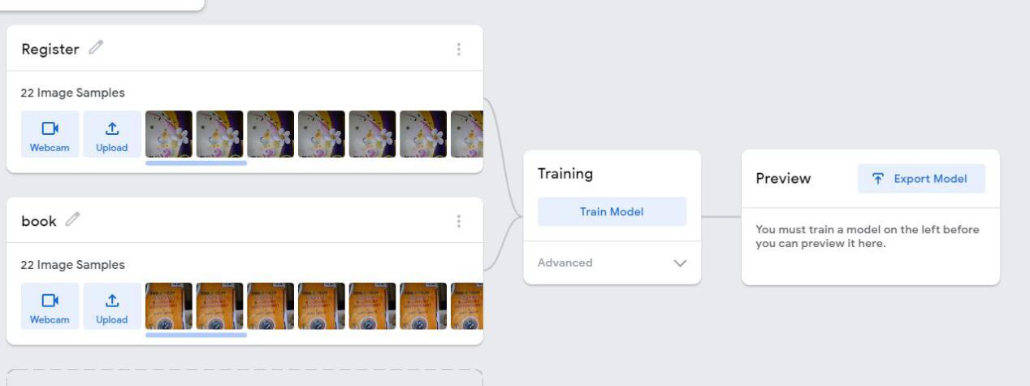

**REFRENCES**

**Refrences:**

[Teachable Machine](https://teachablemachine.withgoogle.com/)

[teachablemachine.withgoogle.com](https://teachablemachine.withgoogle.com/)